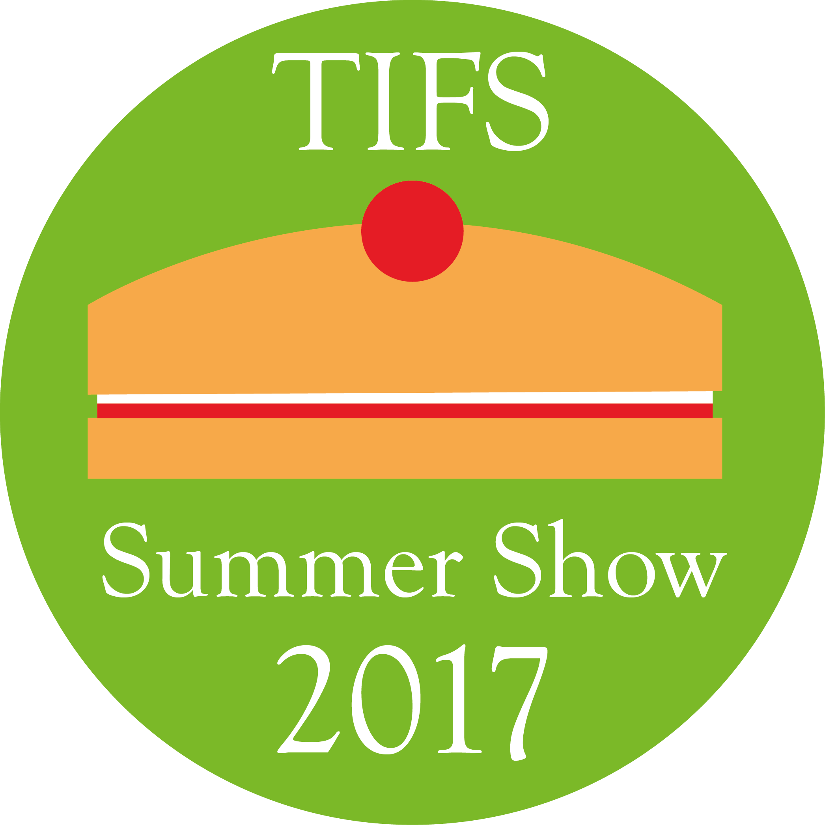
The Island Free School Summer Show 2017

All students are required to submit at least one entry.

Entries are welcomed from adult family members and Staff. Entry forms, rules and further information will be available closer to the Show.

Schedule of Classes

Baking

- A fruit cake – as per recipe provided
- 4 Cherry scones
- 5 Cheese straws in a ring
- 4 jam tarts
- Decorated Madeira sponge, judged for decoration only
- 4 butterfly cakes
- 2 sausage rolls (not jumbo)
- A gluten free cake
- Victoria sponge (3 egg method, no decoration other than caster sugar)
- Pot of jam (wax insert and cellophane lid or new lid)
- A jar of chutney

Craft

- A model of a robot, made from recycled objects
- My best handwriting
- Something new from something old
- A painting of a landscape
- A pencil drawing of still life
- An item of jewellery
- A photograph of an animal
- A photograph of a sunset
- A poem about the beach
- A homemade card, to celebrate ‘a 1st birthday’
- An item from felt, made using the wet felting method
- A cross stitch picture
- A hand sewn item
- An item made from crochet
- A knitted or crocheted toy
- A knitted item of clothing
- Any other item of craft

Vegetables

- 1 cucumber
- 2 courgettes
- 6 runner beans
- 3 carrots (any colour) – short foliage
- 2 onions
- 1 lettuce
- 4 potatoes (main crop)
- 4 potatoes (new)
- 4 ripe cherry tomatoes, stalks left on
- 3 ripe tomatoes, stalks left on
- 1 pepper
- 2 chillies
- One dish of 2 of any other vegetables not mentioned above
- Longest runner bean
- Most misshapen vegetable
- Heaviest potato
- Largest marrow
- Collection of vegetables on a tray (3 different types of any vegetable)
- Any other vegetable

Fruit

- ¼ lb blackcurrants
- 4 raspberries
- 3 strawberries
- Any other fruit

Flowers

- A cactus
- A pot of herbs
- A flower arrangement in a teapot (plant material can be bought)
- A pot plant
- One specimen rose
- One sunflower (cut)
- 3 sweet peas
- A bowl of floating flowers – max diameter 30cm
- A garden on a plate

