Year 7 Gothic Literature Homework Tasks

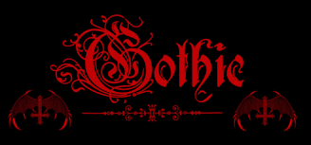
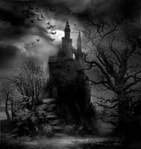
You must choose three tasks to do over the half term.
Hand in dates:
Mondays

- 22nd June

- 6th July

- 20th July
Task 5

Find the titles of five gothic novels and give a short summary of each story. Try to write it as a book review encouraging others to read the books.
Task 6

Write a speech as if you were Dracula. You are in court charged with lots of murders – you must defend yourself and explain why you should be let off. Be prepared to present this speech to the class.

Task 7

Create a short ghost story about ‘The ghost of St. Boniface’. Who is it? Why does it haunt our school? What is the background story to the ghost? You can present it as a newspaper article or as a script for a news report.
Task 8

This can be your homework for all of the weeks. You do not have to do any other homework.
Write a short gothic novel. You may use the computer to type it up and you may illustrate it. Remember to have good character descriptions, lots of suspense and good gothic language.
Task 1

Find ten good gothic words and find ways to illustrate them. Produce them in a way that can be displayed on a classroom board to give inspiration to others. You can use the computer or draw them freely.
Task 4

Find a headline from the County Press or from their website to copy out. Write a news report underneath your headline that puts a gothic ‘twist’ on the story. You can make it as creative as you like but remember to use lots of good gothic vocabulary!
Task 3

Write a detailed account of a time that you have been very scared. Make sure it has lots of detailed emotions and feelings in it.
Task 2

Draw a gothic character and label them with lots of descriptive words or write a page of description next to your picture.

